**ANALOG CIRCUITS PROJECT FOR 3RD IA - 2025**

**Fastest Finger First Circuit using 555 IC For Organizing Quizzes**

**Components Required**

Components Required for Each Module:

* 555 Timer IC
* Momentary Push Button Switch
* PN Diode (I used 1N4148)
* LED + Series Resistor (270R)
* 10K Resistor

Components Common for All Modules:

* 2 x 1K Resistors
* LED + Series Resistor (270R)
* Momentary Push Button (For resetting)
* Breadboard
* Few Breadboards Connectors
* (5-12) V Power Supply

**Circuit Diagram**

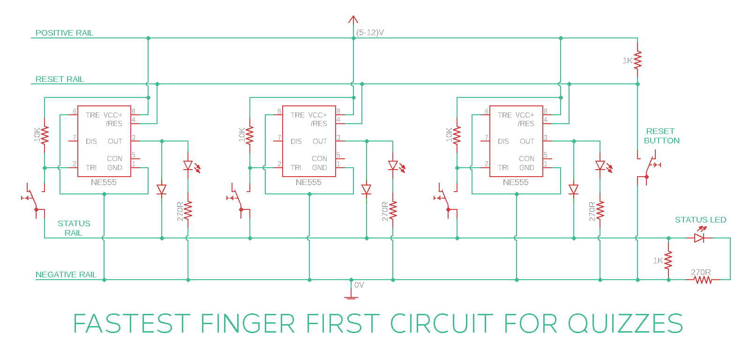

**How This Circuit Works**

Few Basics:

* If Pin-2 of 555 IC sees any voltage less than 1/3rds of the supply voltage, it turns the output ON
* If the reset Pin of 555 IC sees 0V, it resets the output

Apart from positive and negative rails, we used two other rails:

* Reset rail which is pulled up to positive voltage by default using a 1K resistor
* Status / Feedback rail which is pulled down to 0V by default using a 1K resistor. This rail is connected to output of all the modules via diodes. So, this rail will be at 0V by default. But as soon as any of the module’s output is ON, the voltage at this rail reaches positive voltage via the diode

So, when the output of all the modules is in OFF state, the voltage at status rail will be at 0V (default). When any team presses the button, this 0V from status rail is applied at Pin-2. Because 0V is less than 1/3rds of the supply voltage, the output of 555 IC corresponding to the team which pressed the trigger first turns ON.

Immediately after this happens, the voltage at status rail changes to positive voltage because of the feedback via PN diode. So even if other teams press the trigger now, the voltage at Pin-2 of the respective modules will be at positive voltage and the output doesn’t turn ON.

Resetting of states of all the modules is done by applying 0V at the reset pin of all the 555 ICs using reset rail and a dedicated push button.